**Original Saturday night spread factor [2.2, 1.5, 1.1, .75, 0]**

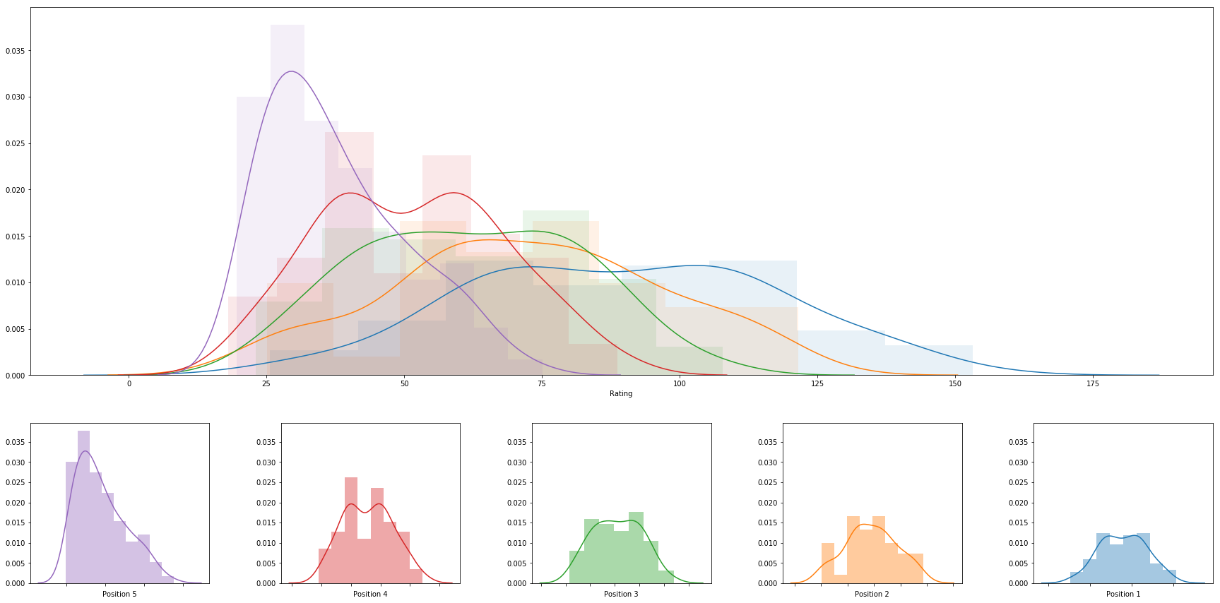

|  |  |  |  |  |  |  |  |
| --- | --- | --- | --- | --- | --- | --- | --- |
|  | **rank** | **name** | **college** | **division** | **rating** | **primary position** | **date** |
| **0** | 1 | Abril Bustamante | USC | DI | 153.19499880517805 | 1 | 2018-05-05 |
| **1** | 2 | Ka'iwi Schucht | Hawaii | DI | 140.02143858194484 | 1 | 2018-05-06 |
| **2** | 3 | Emily Maglio | Hawaii | DI | 140.0214385819448 | 1 | 2018-05-06 |
| **3** | 4 | Megan McNamara | UCLA | DI | 139.9751594138905 | 1 | 2018-05-06 |
| **4** | 5 | Nicole McNamara | UCLA | DI | 139.9751594138905 | 1 | 2018-05-06 |
| **5** | 6 | Victoria Paranagua | Florida State | DI | 137.52062545694494 | 1 | 2018-05-05 |
| **6** | 7 | Tina Graudina | USC | DI | 136.0299939237767 | 1 | 2018-05-05 |
| **7** | 8 | Kristen Nuss | LSU | DI | 133.30895449253163 | 1 | 2018-05-04 |
| **8** | 9 | Claire Coppola | LSU | DI | 133.30895449253163 | 1 | 2018-05-04 |
| **9** | 10 | Vanessa Freire | Florida State | DI | 129.65064649217757 | 1 | 2018-05-05 |
| **10** | 11 | Nele Barber | Long Beach State | DI | 127.80071439624162 | 1 | 2018-04-28 |
| **11** | 12 | Madeline Mertz | Tulane | DI | 126.58595404990098 | 1 | 2018-04-21 |
| **12** | 13 | Kaylie Mchugh | Tulane | DI | 126.58595404990093 | 1 | 2018-04-21 |
| **13** | 14 | Sasha Karelov | Long Beach State | DI | 126.07549410612732 | 1 | 2018-04-28 |
| **14** | 15 | Teegan Van Gunst | Georgia State | DI | 124.40399933699578 | 1 | 2018-04-21 |
| **15** | 16 | Katie Smith | South Carolina | DI | 121.57684266201703 | 2 | 2018-05-04 |
| **16** | 17 | Mima Mirkovic | Cal | DI | 118.35524728666596 | 1 | 2018-04-28 |
| **17** | 18 | Federica Frasca | FIU | DI | 118.21195389267555 | 1 | 2018-05-04 |
| **18** | 19 | Margherita Bianchin | FIU | DI | 118.21195389267555 | 1 | 2018-05-04 |
| **19** | 20 | Annika Van Gunst | Georgia State | DI | 118.04740098725865 | 1 | 2018-04-21 |
| **20** | 21 | Sunny Villapando | Stanford | DI | 117.67010036775945 | 1 | 2018-04-27 |
| **21** | 22 | Jessica Wooten | Houston Baptist | DI | 117.00122991049022 | 1 | 2018-04-22 |
| **22** | 23 | Aeriel Horton | Houston Baptist | DI | 117.00122991049022 | 1 | 2018-04-22 |
| **23** | 24 | Deahna Kraft | Pepperdine | DI | 116.85426689280763 | 2 | 2018-05-05 |
| **24** | 25 | Corinne Quiggle | Pepperdine | DI | 116.85426689280763 | 2 | 2018-05-05 |
| **25** | 26 | Rachel Nieto | Long Beach State | DI | 116.46580356230518 | 2 | 2018-04-28 |
| **26** | 27 | Morgan Martin | Hawaii | DI | 114.37282639484248 | 2 | 2018-05-06 |
| **27** | 28 | Adore Anae | Utah | DI | 113.34497410561478 | 1 | 2018-04-27 |
| **28** | 29 | Dani Barton | Utah | DI | 113.34497410561478 | 1 | 2018-04-27 |
| **29** | 30 | Lily Justine | UCLA | DI | 113.18840917460321 | 2 | 2018-05-06 |
| **30** | 31 | Sarah Sponcil | UCLA | DI | 113.18840917460321 | 2 | 2018-05-06 |
| **31** | 32 | Terese Cannon | USC | DI | 112.14141508112323 | 2 | 2018-05-05 |
| **32** | 33 | Lea Monkhouse | Hawaii | DI | 111.73238760356492 | 2 | 2018-05-06 |
| **33** | 34 | Sammy Slater | USC | DI | 111.45631856143449 | 2 | 2018-05-05 |
| **34** | 35 | Katie Horton | Florida State | DI | 111.34774959540408 | 2 | 2018-05-05 |
| **35** | 36 | Tia Miric | Cal Poly SLO | DI | 110.95951933744388 | 1 | 2018-04-28 |
| **36** | 37 | Torrey Van Winden | Cal Poly SLO | DI | 110.95951933744388 | 1 | 2018-04-28 |
| **37** | 38 | Alexia Inman | Cal | DI | 110.8475856989858 | 1 | 2018-04-28 |
| **38** | 39 | Ali Denney | South Carolina | DI | 109.76428815039202 | 1 | 2018-05-04 |
| **39** | 40 | Shannon Williams | South Carolina | DI | 109.76428815039202 | 1 | 2018-05-04 |
| **40** | 41 | Olivia Macdonald | Arizona | DI | 109.6422634771407 | 1 | 2018-04-27 |
| **41** | 42 | Natalie Anselmo | Arizona | DI | 109.6422634771407 | 1 | 2018-04-27 |
| **42** | 43 | Hailey Luke | Florida State | DI | 108.95598075713967 | 2 | 2018-05-05 |
| **43** | 44 | Brook Bauer | Pepperdine | DI | 108.52415640294171 | 1 | 2018-05-05 |
| **44** | 45 | Madalyn Roh | Pepperdine | DI | 108.52415640294168 | 1 | 2018-05-05 |
| **45** | 46 | Kimmy Gardiner | Washington | DI | 107.96065354476647 | 1 | 2018-04-28 |
| **46** | 47 | Jordan Anderson | Washington | DI | 107.9606535447664 | 1 | 2018-04-28 |
| **47** | 48 | Carly Kan | Hawaii | DI | 107.87767913638936 | 3 | 2018-05-06 |
| **48** | 49 | Morgan Hughes | Saint Mary's | DI | 107.123541671962 | 1 | 2018-04-21 |
| **49** | 50 | Payton Rund | Saint Mary's | DI | 107.123541671962 | 1 | 2018-04-21 |
| **50** | 51 | Cadie Bates | South Carolina | DI | 106.66442911285307 | 2 | 2018-05-04 |
| **51** | 52 | Maddy Kline | UNC Wilmington | DI | 106.04642907554506 | 1 | 2018-04-21 |
| **52** | 53 | Nicole Lott | UNC Wilmington | DI | 106.04642907554506 | 1 | 2018-04-21 |
| **53** | 54 | Haleigh Nelson | LSU | DI | 106.01703065400024 | 2 | 2018-05-04 |
| **54** | 55 | Sammee Thomas | Stetson | DI | 105.2780587312191 | 1 | 2018-04-21 |
| **55** | 56 | Darby Dunn | Stetson | DI | 105.2780587312191 | 1 | 2018-04-21 |
| **56** | 57 | Laurel Weaver | Hawaii | DI | 104.9793363475992 | 3 | 2018-05-06 |
| **57** | 58 | Savannah Slattery | LMU | DI | 104.74433758081805 | 1 | 2018-04-21 |
| **58** | 59 | Jessica Gaffney | Cal | DI | 104.66798919562808 | 2 | 2018-04-28 |
| **59** | 60 | Emily Sonny | Cal Poly SLO | DI | 103.9096941137134 | 2 | 2018-04-28 |
| **60** | 61 | McKayla Ferris | LMU | DI | 103.77266646152745 | 1 | 2018-04-21 |
| **61** | 62 | Molly Turner | Grand Canyon | DI | 103.54848301327755 | 1 | 2018-04-19 |
| **62** | 63 | Sara Putt | Florida State | DI | 103.33908152532942 | 3 | 2018-05-05 |
| **63** | 64 | Cassie House | TCU | DI | 103.17769457927898 | 1 | 2018-04-15 |
| **64** | 65 | Haven Hill | TCU | DI | 103.17769457927898 | 1 | 2018-04-15 |
| **65** | 66 | Kenley Adams | UAB | DI | 102.92187748961263 | 1 | 2018-04-21 |
| **66** | 67 | Devon May | UAB | DI | 102.50748070982031 | 1 | 2018-04-21 |
| **67** | 68 | Amelia Smith | Stanford | DI | 101.70203169501184 | 2 | 2018-04-27 |
| **68** | 69 | Morgan Hentz | Stanford | DI | 101.7020316950118 | 2 | 2018-04-27 |
| **69** | 70 | Sam Manley | Cal Poly SLO | DI | 101.65938257444292 | 2 | 2018-04-28 |
| **70** | 71 | Destiny Julye | Washington | DI | 100.71356421877593 | 2 | 2018-04-28 |
| **71** | 72 | Courtney Schwan | Washington | DI | 100.49682858696407 | 2 | 2018-04-28 |
| **72** | 73 | Tiffany Creamer | Georgia State | DI | 100.39662903059744 | 2 | 2018-04-21 |
| **73** | 74 | Hannah Towne | Grand Canyon | DI | 99.30219555103812 | 1 | 2018-04-19 |
| **74** | 75 | Carly Scarborough | FAU | DI | 98.58785957279623 | 1 | 2018-04-21 |
| **75** | 76 | Macy Jerger | Florida State | DI | 97.3603066037522 | 3 | 2018-05-05 |
| **76** | 77 | Iya Lindahl | Cal | DI | 96.2711868417031 | 2 | 2018-04-28 |
| **77** | 78 | Savvy Simo | UCLA | DI | 95.9821098393505 | 3 | 2018-05-06 |
| **78** | 79 | Megan Kruidhof | Long Beach State | DI | 95.56336485974748 | 2 | 2018-04-28 |
| **79** | 80 | Courtney Bowen | Stanford | DI | 95.47725893558818 | 3 | 2018-04-27 |
| **80** | 81 | Katja Ehlers | College of Charleston | DI | 95.22199307146086 | 1 | 2018-04-21 |
| **81** | 82 | Jessie Prichard | LMU | DI | 95.11225922158961 | 2 | 2018-04-21 |
| **82** | 83 | Emily Bible | Saint Mary's | DI | 94.04470056532011 | 2 | 2018-04-21 |
| **83** | 84 | Lindsey Knudsen | Saint Mary's | DI | 94.0447005653201 | 2 | 2018-04-21 |
| **84** | 85 | Brooke Weiner | Georgia State | DI | 93.97180100428903 | 2 | 2018-04-21 |
| **85** | 86 | Sara Kovac | LMU | DI | 93.85758783617642 | 2 | 2018-04-21 |
| **86** | 87 | Amanda Silva | FAU | DI | 93.57859063590543 | 1 | 2018-04-21 |
| **87** | 88 | Hunter Domanski | LSU | DI | 93.09133701454378 | 3 | 2018-05-04 |
| **88** | 89 | Carina Hoff | UNF | DI | 92.5227651210882 | 1 | 2018-04-21 |
| **89** | 90 | Courtney Miller | UNF | DI | 92.5227651210882 | 1 | 2018-04-21 |
| **90** | 91 | Sunniva Helland-Hansen | Stetson | DI | 91.97550316589204 | 2 | 2018-04-21 |
| **91** | 92 | Carly Perales | Stetson | DI | 91.97550316589204 | 2 | 2018-04-21 |
| **92** | 93 | Lan Nguyen | Tulane | DI | 91.87517144308352 | 2 | 2018-04-21 |
| **93** | 94 | Haley Hallgren | USC | DI | 91.60672882593896 | 3 | 2018-05-05 |
| **94** | 95 | Janell Walley | Boise State | DI | 91.45421902684393 | 1 | 2018-04-21 |
| **95** | 96 | Sabryn Roberts | Boise State | DI | 91.45421902684393 | 1 | 2018-04-21 |
| **96** | 97 | Krissy Mummey | College of Charleston | DI | 91.23585639251817 | 1 | 2018-04-21 |
| **97** | 98 | Amanda Carroll | FGCU | DI | 91.23032550280354 | 1 | 2018-04-21 |
| **98** | 99 | Mackenzie Allen | FGCU | DI | 91.23032550280354 | 1 | 2018-04-21 |
| **99** | 100 | Mia Rivera | ASU | DI | 91.20731225620005 | 1 | 2018-04-27 |